Lesson 2 Homework  FRONT PAGE | LT 5.1 and 5.2 | 3, 7-12, 19, 20 (FRONT)  3-11 odd, 16, 31 (BACK PAGE)

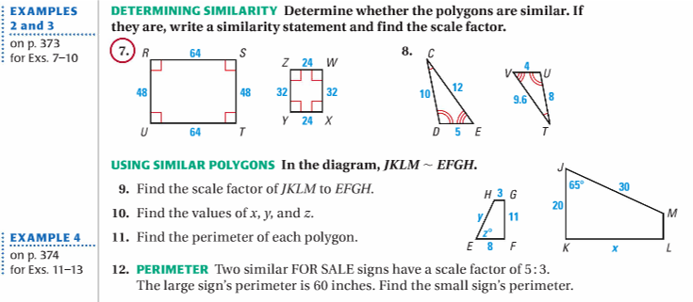
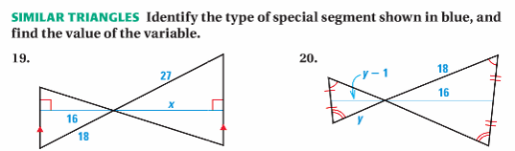

Lesson 2 Homework  BACK PAGE | LT 5.1 and 5.2 | 3, 7-12, 19, 20 (FRONT)  3-11 odd, 16, 31 (BACK PAGE

